LAB ASSIGNMENT 7

U24CS076

RUSHANG BAGADA

Q1: Write a program to demonstrate different data types in python.

**age = 25**

**print("Integer:", age)**

**height = 5.9**

**print("Float:", height)**

**name = "Alice"**

**print("String:", name)**

**fruits = ["apple", "banana", "cherry"]**

**print("List:", fruits)**

**coordinates = (10.0, 20.0)**

**print("Tuple:", coordinates)**

**person = {**

**"name": "Bob",**

**"age": 30,**

**"city": "New York"**

**}**

**print("Dictionary:", person)**

**unique_numbers = {1, 2, 3, 2, 1}**

**print("Set:", unique_numbers)**

**is_student = True**

**print("Boolean:", is_student)**

**nothing = None**

**print("NoneType:", nothing)**

**print(f"Type of age: {type(age)}")**

**print(f"Type of height: {type(height)}")**

**print(f"Type of name: {type(name)}")**

**print(f"Type of fruits: {type(fruits)}")**

**print(f"Type of coordinates: {type(coordinates)}")**

**print(f"Type of person: {type(person)}")**

**print(f"Type of unique_numbers: {type(unique_numbers)}")**

**print(f"Type of is_student: {type(is_student)}")**

**print(f"Type of nothing: {type(nothing)}")**

OUTPUT:

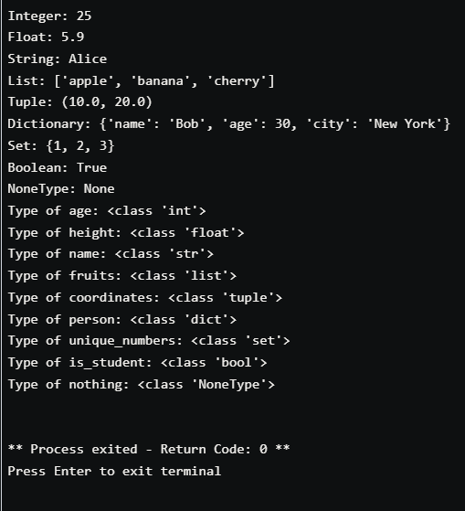

Q2: Write a program to perform different arithmetic operations on numbers in python.

num1 = float(input("Enter first number: "))

num2 = float(input("Enter second number: "))

print("Addition:", num1 + num2)

print("Subtraction:", num1 - num2)

print("Multiplication:", num1 * num2)

print("Division:", num1 / num2)

Output:

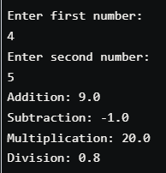

Q3: Create a list and perform the following methods 1) insert() 2) remove() 3) append() 4) len() 5) pop() 6) clear()

list1 = [1,2,3,4,5]

print(list1)

list1.insert(2,6)

print(list1)

list1.remove(6)

print(list1)

list1.append(7)

print(list1)

print(len(list1))

list1.pop()

print(list1)

list1.clear()

print(list1)

output:

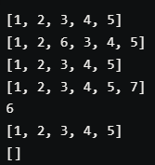

Q4:Create a dictionary and apply the following methods 1) Print the dictionary items 2) access items 3) use get() 4) change values 5) use len()

dict1 = {'name': 'Alice', 'age': 25, 'city': 'New York'}

print(dict1)

print(dict1['name'])

print(dict1.get('age'))

dict1['age'] = 30

print(dict1)

print(len(dict1))

output:

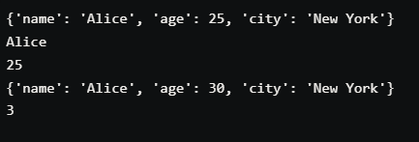

Q5: Write a program to create, concatenate and print a string

str1 = "Hello"

str2 = "World"

str3 = str1 + str2

print(str3)

output:



Q6: Write a python program to add two numbers.

num1 = float(input("Enter first number: "))

num2 = float(input("Enter second number: "))

sum = num1 + num2

print("The sum of", num1, "and", num2, "is", sum)

output:

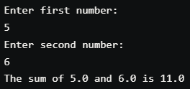

Q7: Write a python program to print a number is positive/negative using if-else.

num = int(input("Enter a number: "))

if num > 0:

    print("positive number.")

else:

    print("negative number.")

output:

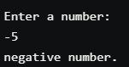

Q8: Write a python program to find largest of three numbers

num1 = float(input("Enter first number: "))

num2 = float(input("Enter second number: "))

num3 = float(input("Enter third number: "))

if num1 > num2 and num1 > num3:

    print(num1, "is the largest number.")

elif num2 > num1 and num2 > num3:

    print(num2, "is the largest number.")

else:

    print(num3, "is the largest number.")

output:

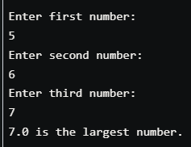

Q9: Python program for factorial of a number

num = int(input("Enter a number: "))

factorial = 1

if num < 0:

    print("Factorial does not exist for negative numbers.")

elif num == 0:

    print("Factorial of 0 is 1.")

else:

    for i in range(1, num + 1):

        factorial *= i

    print("Factorial of", num, "is", factorial)

output:  
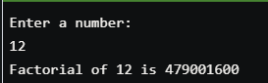

Q10: Python program for simple interest

p = float(input("Enter the principal amount: "))

r = float(input("Enter the rate of interest: "))

t = float(input("Enter the time period: "))

si = (p * r * t) / 100

print("The simple interest is:", si)

output:

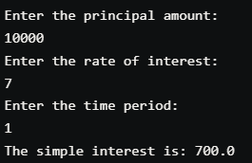

Q11: Python program to check Perfect Number (Example: 6, divisors of 6 are 3,2,1 and sum of divisors is the number itself)

num = int(input("Enter a number: "))

sum = 0

for i in range(1, num):

    if num % i == 0:

        sum += i

if sum == num:

    print(num, "is a perfect number.")

else:

    print(num, "is not a perfect number.")

output:

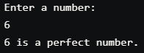

Q12: Python program to calculate grade of a student. Take in the marks of 5 subjects

and  display the grade

marks1 = float(input("Enter marks of sub1: "))

marks2 = float(input("Enter marks of sub2: "))

marks3 = float(input("Enter marks of sub3: "))

marks4 = float(input("Enter marks of sub4: "))

marks5 = float(input("Enter marks of sub5: "))

marks = (marks1 + marks2 + marks3 + marks4 + marks5) / 5

if marks >= 90 and marks <= 100:

    print("Grade: A")

elif marks >= 80 and marks < 90:

    print("Grade: B")

elif marks >= 70 and marks < 80:

    print("Grade: C")

elif marks >= 60 and marks < 70:

    print("Grade: D")

else:

    print("faliled")

output:

